**MY TEST OUTCOMES:**

##### **PERSONALITY, CREATIVITY AND LEARNING STYLE TESTS**

## The Myers and Briggs Personality Test (Courtesy of 16Personalities)

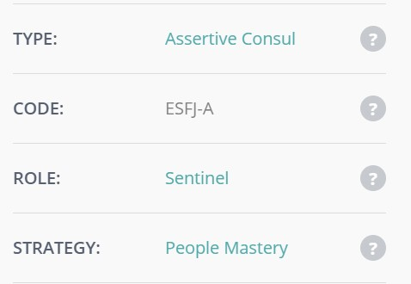

**Creativity Test (Courtesy of MindTools)**

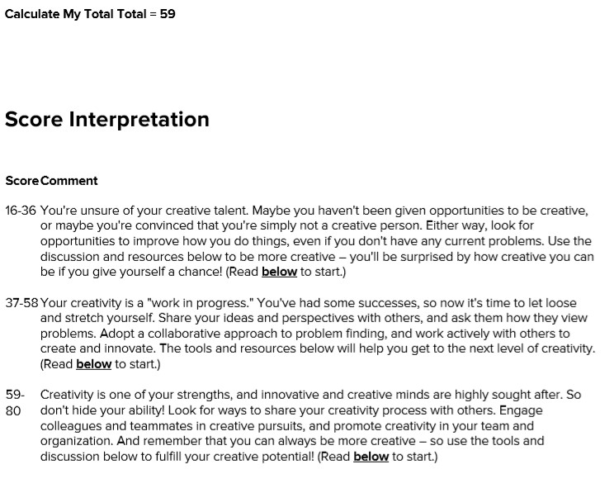

#### **What is your Learning Style (Courtesyof EducationPlanner.org)**

